# COS20019 Cloud Computing Architecture

Assignment 2: Developing a highly available photo album website.

# Student Name: Harry

# Student ID: 103517299

I.Introduction

The purpose of this report is to document the successful completion of Assignment 2, which involved extending and modifying the infrastructure and program developed in Assignment 1B. This assignment introduced various AWS services and required the creation of IAM roles, S3 bucket policies, Lambda functions, custom AMIs, and more. The assignment was divided into two main tasks: modifying the functional requirements of the Photo Album website and modifying the infrastructure.

II.Infrastructure Deployment

Website URL’s:

AlbumURL: <http://54.158.242.24/photoalbum/album.php>

Photouploader: <http://54.158.242.24/photoalbum/photouploader.php>

Via ELB: <http://harryelb-1138575661.us-east-1.elb.amazonaws.com/photoalbum/album.php>

The infrastructure was set up according to the provided architecture diagram, and several components were configured:

VPC:

-Created a VPC with two availability zones, public and private subnets.

-Configured routing tables to route traffic to internet gateways and NAT instances/gateways

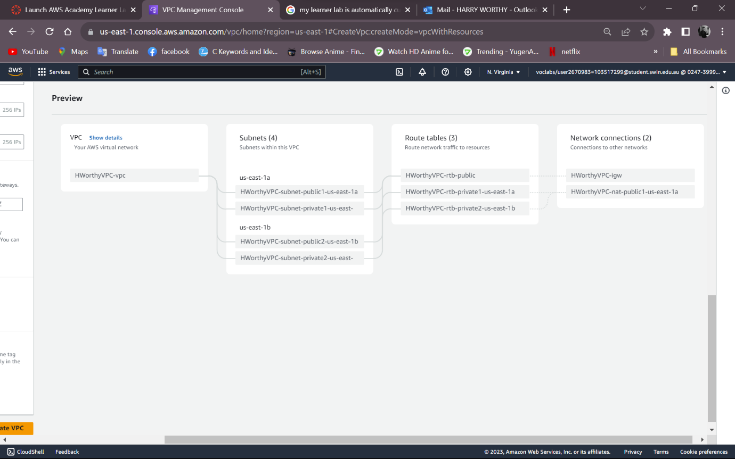

Route table:

Security Groups & Network ACL:

- security groups for ELB, web servers, RDS, NAT, and Dev server.

-Designed a Network ACL to control ICMP traffic between subnets.

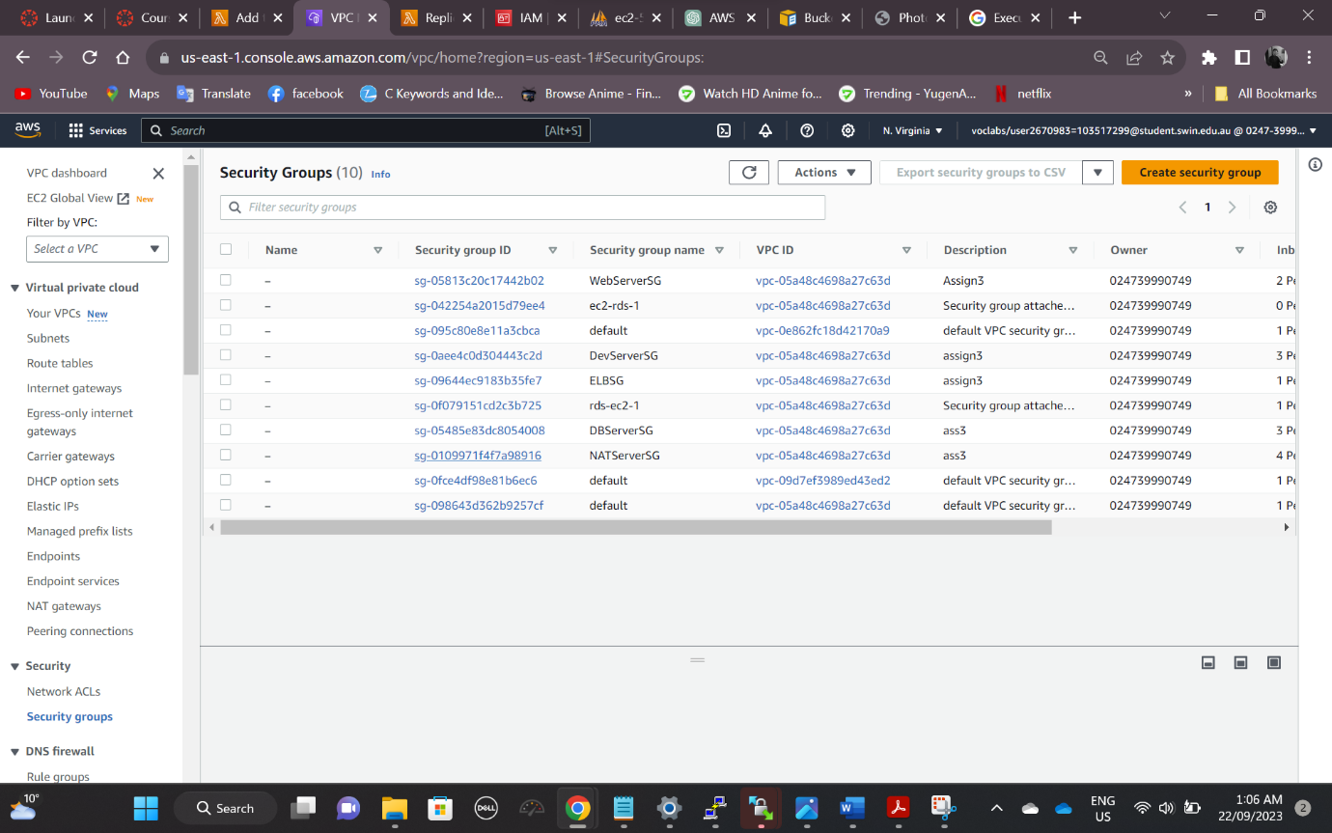

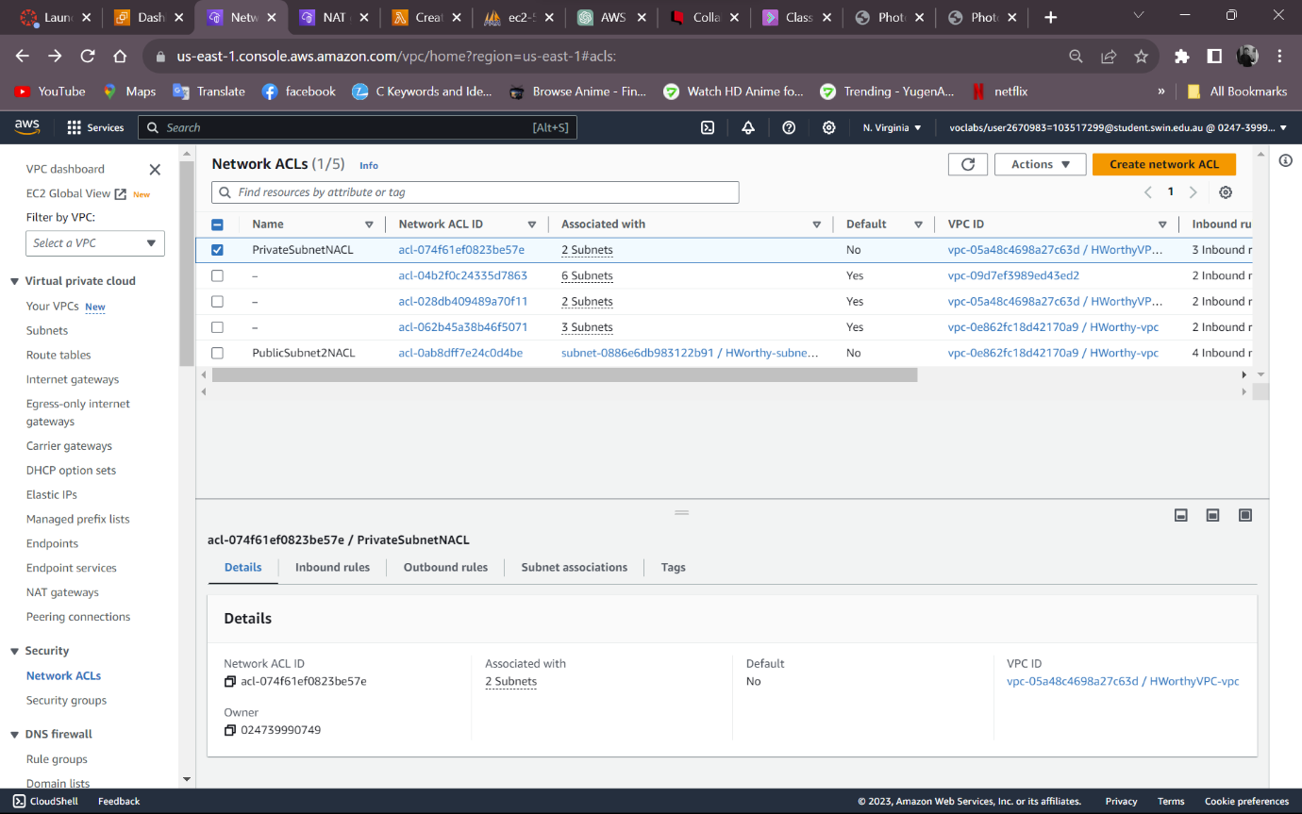

EC2 Instance & IAM Role:

-Configured EC2 web server instances with Amazon Linux 2 AMI and proper IAM roles.

-Instances were automatically launched and served Photo Album users.

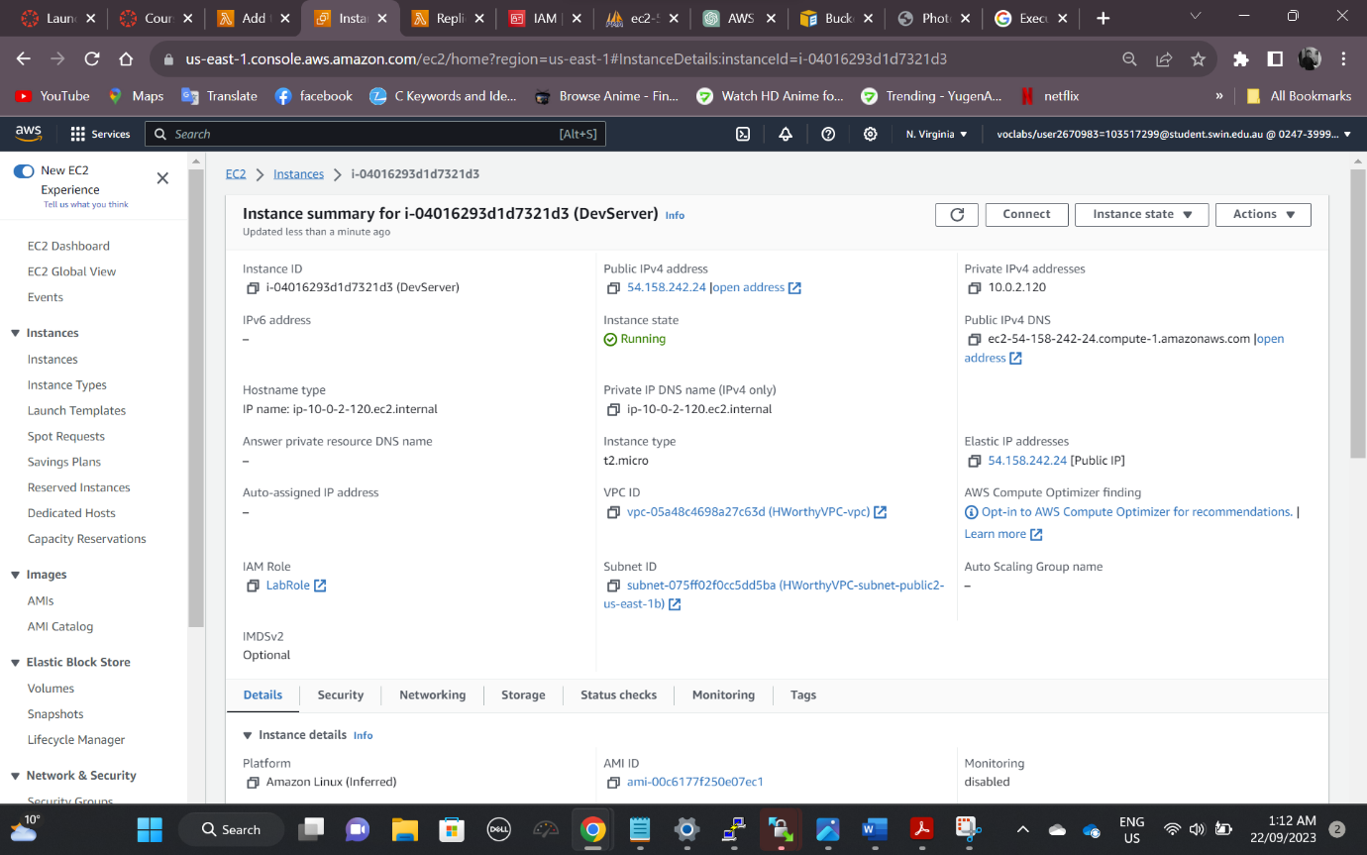

ASG:

-Defined auto scaling policies to maintain server count based on target tracking.

-Instances were launched into private subnets.

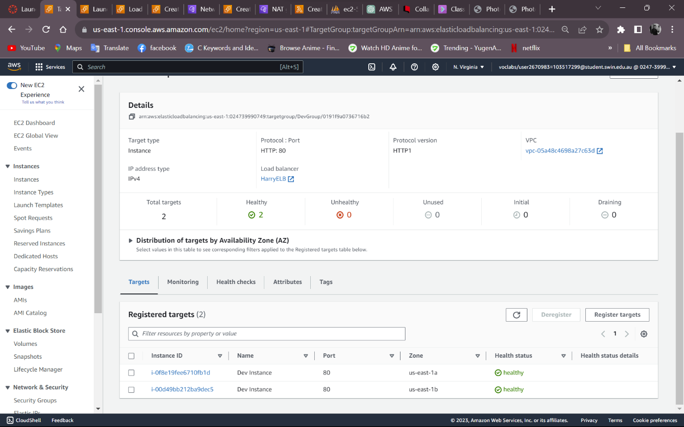

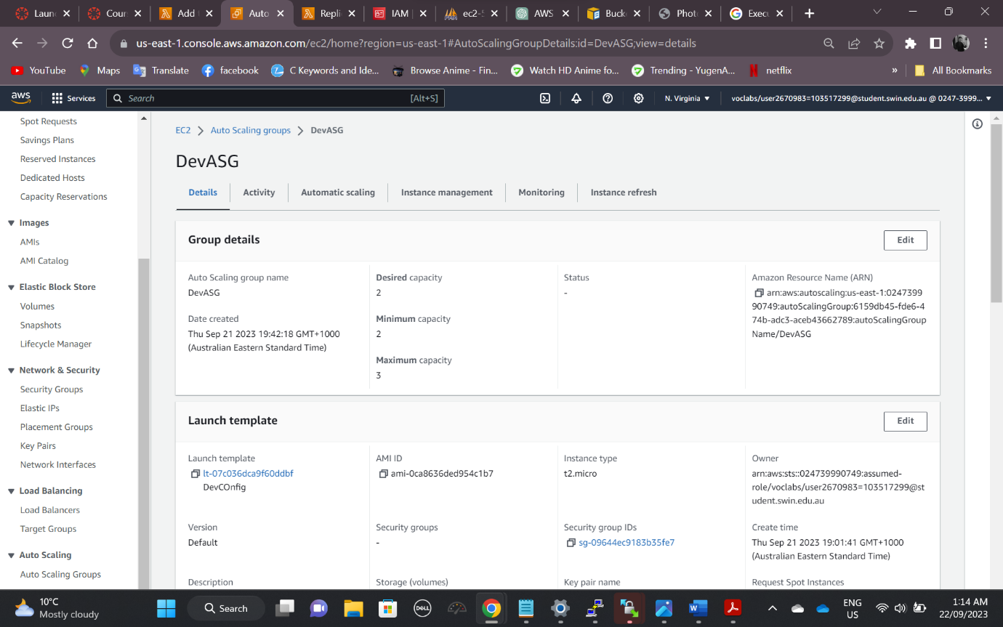

ELB:  
HarryELB-1138575661.us-east-1.elb.amazonaws.com

-Implemented a Load Balancer for distributing web traffic.

-Configured health checks to monitor instances.

S3 Bucket:

-Ensured that photos were stored securely in an S3 bucket, restricting access using bucket policies.

Lambda Config:

-Created a Lambda function with appropriate IAM roles to interact with S3.

-Deployed the Lambda function to resize and store images in S3.

RDS:

III.Testing

A comprehensive testing process was conducted to validate the functionality of the deployed infrastructure:

-Verified accessibility of the Photo Album website through the ELB.

-Tested photo uploads and confirmed database records.

-Checked S3 bucket for uploaded photos and resized versions.

-Ensured direct access to S3 photos was restricted.

-Tested Network ACL functionality for ICMP traffic control.

-Validated that security groups and IAM roles adhered to the least-privilege principle.

Website accessible via ELB:

AlbumURL: <http://54.158.242.24/photoalbum/album.php>

Photouploader: <http://54.158.242.24/photoalbum/photouploader.php>

Via ELB: <http://harryelb-1138575661.us-east-1.elb.amazonaws.com/photoalbum/album.php>

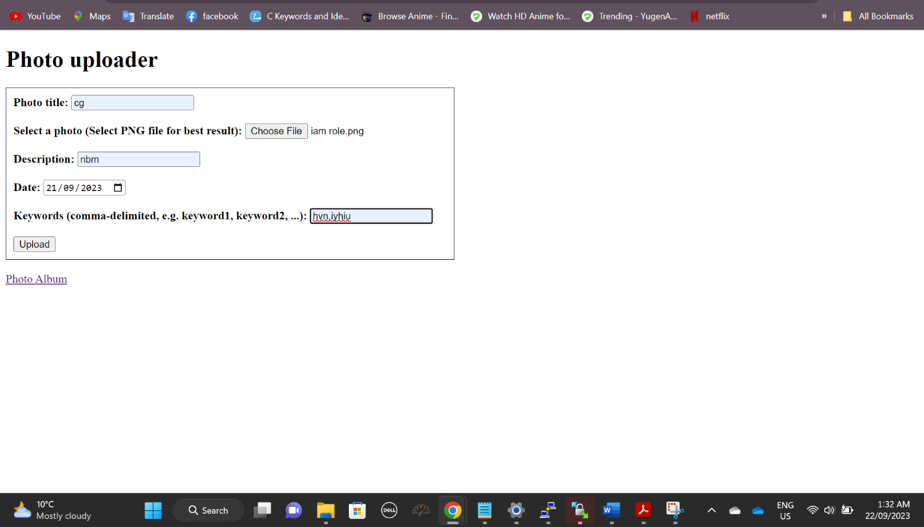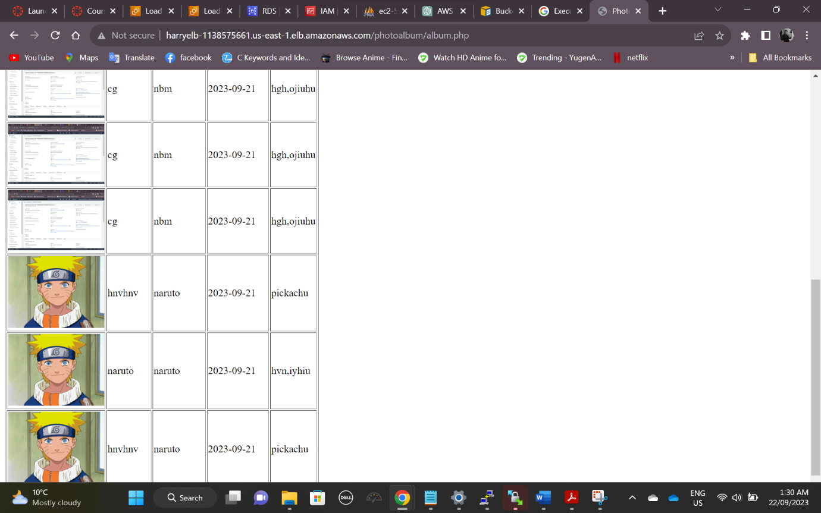

III.Conclusion

In conclusion, Assignment 2 involved extending and modifying an existing infrastructure and program to create a highly available Photo Album website on AWS. By successfully completing this assignment, I have gained valuable experience in AWS service configuration and deployment, security practices, and web application development in a distributed environment.